

Webmail 6.0 | User Guide
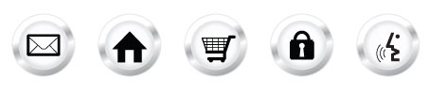

Legend
= Important Notes
= Technical Information
= Feature Specifications

Table of Contents

Overview 4
What is WebMail 6.0? 4
Login to WebMail 6.0 4
The WebMail 6.0 Main Screen 5
5
Main Menu 6
Secondary Menu 6
Feature Details 6
Home 7
1) Organize Inbox Layout 8
2) View Messages 12
New 12
3) Compose Messages 13
4) Get Mail 17
5) Delete Mail 17
6) Mark as spam 18
7) Move Messages 18
Contacts 18
1) View Contacts 19
2) Create Contacts 20
3) Edit Contacts 20
4) Delete Contacts 21
5) Create Groups 21
6) Edit Groups 21
7) Delete Groups 22
Calendar 23
2) View the Calendar 25
4) View Events 32
5) Edit Events 32
6) Delete Events 32
7) Create a New Calendar 33
3. Fill out the fields. The more fields you fill out the better as it will enhance your search results. 34
Notes 36
1) List Notes 36
2) New Note 36
36
3) New Notepad 36
Mobile 38
1) SyncSuite 38
2) Mobile Email 38
Preferences 39
1) Mail Preferences 40
2) Spam Preferences 41
3) Allow/Block Lists 43
3) Change Password 44
4) Auto Reply Messages 44
6) Highlighting Messages 48
1. Enter a name for your rule. 48
There are several options available to choose from: 49
Find Messages 49
Manage Personal Folders 50
WebMail 6.0 for PDAs 52
1) Login 52
2) Message View 53
3) Compose 54
4) Language Support 55
5) Log Out 56
Disk Usage & Collaborative Services FAQ 57

Overview

What is WebMail 6.0?

WebMail 6.0 is an online email client which runs in your web browser. WebMail 6.0 allows you to access your email, contact list, and calendar from any computer with an internet connection and a web browser.

Login to WebMail 6.0
  - Enter your full email address
  - Enter your email password
  - Click the “Login” button to access WebMail 6.0.

Webmail 6.0 Login

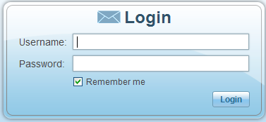

If your user information is incorrect, the login page will be re-displayed stating: “Incorrect username/password. Please try again.” Please verify that you are using your full email address such as johndoe@domain.com and that you have the correct password.

The WebMail 6.0 Main Screen
The Main Screen allows you to navigate through a Main Menu, access Quick Links and view Statistics.

WebMail 6.0 Main Screen

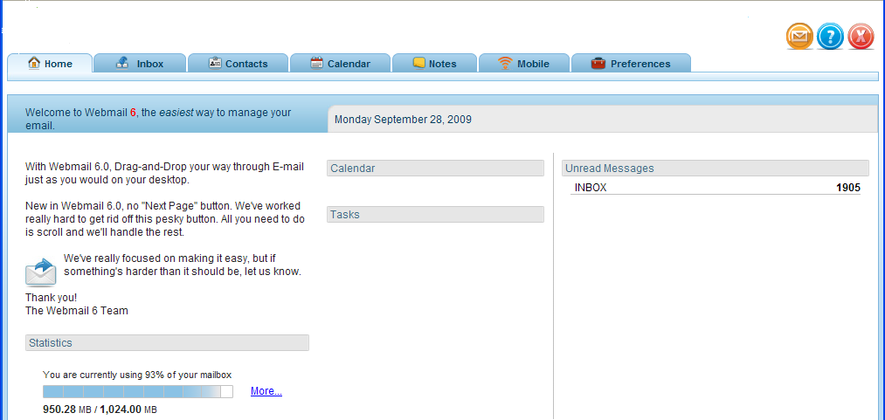
Help
Logout
Statistics
Feedback

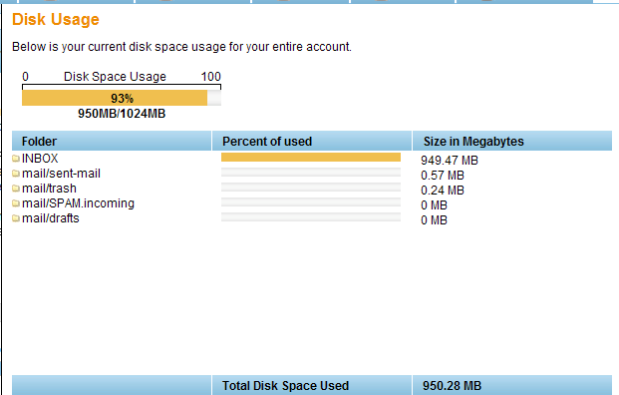

Main Menu

On the top left of the screen of the WebMail 6.0 interface there is a static Main Menu:

- Home
- Inbox
- Contacts
- Calendar
- Notes
- Mobile
- Preferences

Main Menu

You may access any one of these functions at anytime by clicking the tab on the Main Menu bar.

Secondary Menu

The Secondary Menu is located directly underneath the Main Menu. The Secondary Menu changes with each selection made within the Main Menu

Secondary Menu

Clicking the “Home” icon from any feature screen will take you back to the WebMail 6.0 Main Screen.

Feature Details

The Main Menu in WebMail 6.0 navigates you through several options:

- Home
- Inbox
- Contacts
- Calendar
- Notes
- Mobile
- Preferences

Each section is described in detail below.

Home

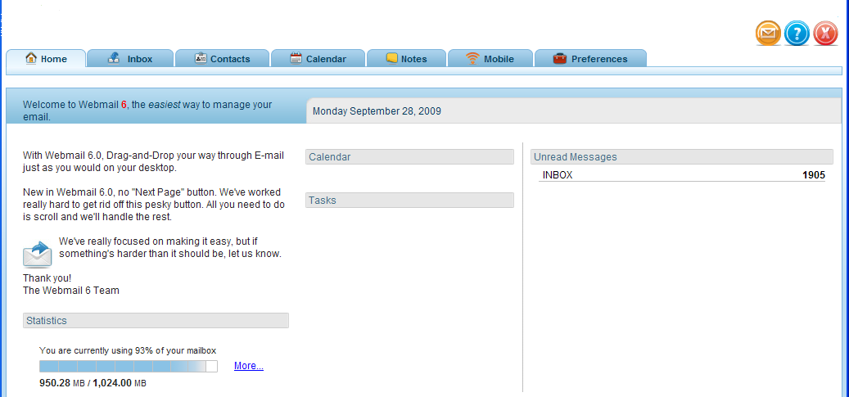

The “Home” section displays information about your calendar and the account of your new messages.

Inbox

The Inbox section is used to view, send and manage email messages.
You are able to perform the following tasks in the Mailbox:

- Organize Inbox Layout
- View Messages
- Compose Messages
- Check Mail
- Delete Mail
- Find Messages
- Manage Personal Folders
- Move or Copy Messages
Secondary Inbox Menu

1) Organize Inbox Layout
The layout of the WebMail 6.0 Inbox interface is comprised of 3 Panels by default
- Mail Folders Panel: situated on the left of the screen.
- Mail Listing Panel: situated at the top right of the screen.
- Mail Preview Panel: situated at the bottom right of the screen.
Inbox

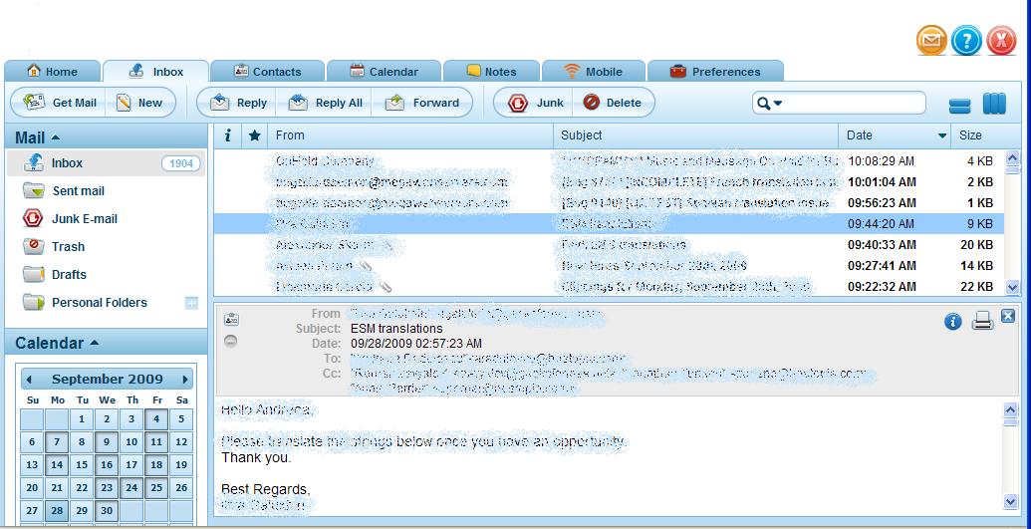
Mail Folder Panel
Mail Preview Panel
Mail Listing Panel

- Mail Folders Panel
The messages contained in the selected folder will be displayed in the Mail Listing Panel. To switch to a different folder, click the folder icon or name.

Mail Folders
The Mail Folders Panel displays the following default folders:
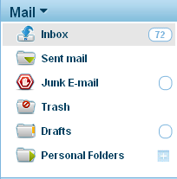
  - Inbox
  - Sent Mail
  - Junk Email
  - Trash
  - Drafts
  - Personal Folders

.
You can increase the loading speed of your WebMail 6.0 account by limiting the size of your Inbox. To do this you may wish to delete unwanted messages from your Inbox or place them in personal folders.

Folder Options
To display the folder options, right-click the folder icon or name. For all folders except “Personal Folders,” the following options will be displayed:

- Mark All Messages as Read: This option will mark all messages in the folder, including any new messages, as having been viewed.

- Mark All Messages as Unread: This option will mark all messages in the folder, including any old messages, as not having been viewed.

- Empty Folder: This option will move all messages into the Trash folder. You may still view and recover the messages from the Trash folder.
Folder Options

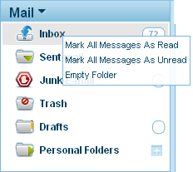
Right-Click

Hide or Show the Mail Folders Panel:

- Hide: Click the down-pointing arrow in the “Mail Folders Panel” title bar. This will hide the “Mail Folders Panel”.

- Show: Click the down-pointing arrow in the “Mail Folders Panel,” title bar. This will show the “Mail Folders Panel”.

Click to Hide
Hide Mail Folders
Click to Show
Show Mail Folders

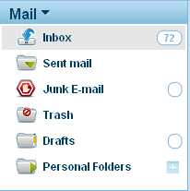

- Mail Listing Panel
The Mail Listing Panel displays email information, by clicking on “From,” Subject,” “Date,” and “Size,” you will be able to sort in ascending or descending order.
Message Listing Bar

Message Listing Bar | Description
Select All | You can select more than one message by using the Shift key on your keyboard.
 | Will display the message source.
 | You can click on this icon in order to mark messages for follow up.
Message status | The message status will be indicated with an icon in the second column. The following icons may be displayed:  None  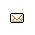  - Seen: indicates the message has been seen.  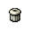  - Unseen: indicates the message has not been seen  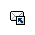  - Deleted: indicated the message has been deleted  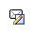  - Answered: indicated the message has been replied to.  - Draft: indicated the message has been saved as a draft.  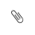  - Attachment: indicates the message contains an attachment.
From | The sender of the message will be displayed in this column.
Subject | The subject line of the message will be displayed in this column.
Date | The date the message has been received by the server will be displayed in this column.
Size | The size of the message, including all body text and attachments, will be displayed in this column.
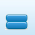 | Horizontal view of the email message. (Mail Listing Panel on top and Mail Preview Panel on the bottom)
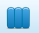 | Vertical view of the email message (Mail Listing Panel on the left and Mail Preview Panel on the right)

C) Mail Preview Panel
Click on an email you wish to view in the Mail Listing Panel. The Mail Preview Panel displays the contents of a selected message. For the selected message, the following information is displayed:
  - Header Fields (i.e. To, From, Subject, Date)
  - Attachments
  - Message Body
Show image/styles, Message source, Print

Header Fields
Mail Preview Panel
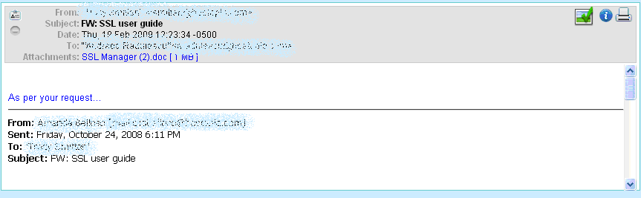
Attachment
Message
Body

Click on to add the contact to your address book.
Click on to hide/show the Header fields of the email message

Resizing Panels
You man change the size of the panels by dragging the bars that separate each panel.
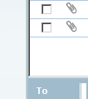
Drag Bar
Up or Down
Drag Bar Left or Right
Resize Panels

2) View Messages

To view a message, click on any part of the message listing in the Mail Listing Panel. This will display the message in the Mail Preview Panel.

To view a message in a new window, double click any part of the message listing in the Mail Listing Panel. This will open a new window and display the message.

To view or save message attachments, click the attachment link icon in the Message Preview Panel while the message is displayed.

New

When you click “New” the Compose new message window will be displayed.

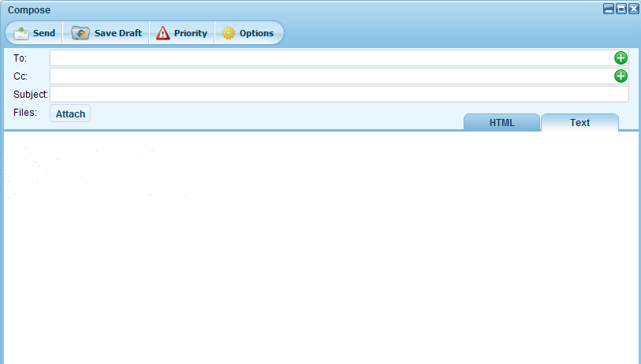

Here you will be able to compose an email message and send it to selected recipient(s).

3) Compose Messages

From the Secondary Menu you may select one of the available ways to begin composing a message:
Composing Mail

Secondary Menu | Description
New | To compose a new message, click “New” from the Secondary Menu.
Reply | To reply to a received message, you must first select the message from the Mail Listing Panel. Once a message is selected, click the “Reply” button in the Secondary Menu.  This will open a Compose window with the following fields completed:  - The To field will contain the sender’s email address  - The Subject field will contain the message’s subject line preceded by “Re:“ for “Reply”  - The Body field will contain the message’s body indented to the right
Reply All | It has the same functionality as “reply” except that in this case the “To” field will contain the sender’s email address and all the email addresses that appear in the “CC” field of the received email message.
Forward | To forward a received message to other recipients, you must first select the message from the Mail Listing Panel. Once a message is selected or displayed, click the “Forward” button in the Secondary Menu.  This will open a Compose window with the following fields completed:  - The Subject field will contain the message’s subject line preceded by “Fw: “for “Forward”.  - The Body field will contain the message’s body.
Junk | To move a message to the junk folder, you must first select the email message and then click on “Junk”. The email message will be moved to the “Junk” folder.
Delete | To delete a message, you must first select the email message and then click on “Delete”. The email message will be deleted and moved to the “Trash” folder.

The Compose Window

The Compose Window allows you to perform the following tasks:

- Select Recipient(s)
- Type Subject
- Select Message Format (HTML, Text)
- Save Message Copy
- Type Body
- Spell Check
- Include Attachment(s)
- Save Draft
- Send Message
- Priority setting

Compose Window

- Select Recipient(s)
There are three locations where you can place the email addresses of your recipients:

Recipient Locations | Descriptions
To: | In the textbox to the right of the “To:” field, place the email address of your recipients.
CC: | In the textbox to the right of the “CC:” field, place the email address of the recipients you would like sent a copy of your message to.
BCC: | In the textbox to the right of the “BCC:” field, place the email address of the recipients you would like sent a copy of your message to without the other recipients (To: or CC :) seeing the addresses placed in this field.

Auto complete remembers your email contacts you have previously entered into the TO, CC, BCC Fields. Type in a portion of the email address, a drop down menu with matching or similar contact will be listed, click on the email address to accept.

Contacts

Click to Close
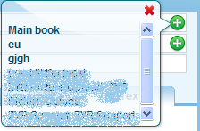

Click Add Contact

Select Contact List

- Type Subject
Type the subject of your message in the textbox on the right of the “Subject:” label.

- Select Message Format
There are two formats in which you may compose your message:
  - Text: This option allows you type your message in plain text without any special formatting.
  - HTML: This option allows you to type your message using HTML code to specify special formatting. You may change the font face, size, color and weight as well as include bullets, indents, text justification and background color.

- Save Message Copy
To save a copy of the message you are sending, check the “Save a copy in ‘Sent Mail’”. This will place a copy of your message in the Sent Mail folder.

- Type Body
In the main text area, type the content of your message. Any spelling errors will be underlined with red.

g) Include Attachment(s)
To attach a document to your message, click the “Attach” icon. This will display the “Upload Attachment” menu. Click “Browse” to the select the document from your computer. Click “Attach” to attach the document to the message or click the “Attach” icon again to cancel the attachment process.

Attachments

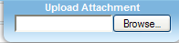
Click Browse to Select File

If a file has been attached, the “Upload Attachment” menu will close and the path to the document will appear next to File.

Attachment List

Attachments Listed

To remove an attachment, click the Remove button located besides the attachment name.

h) Save Draft
To save your message without sending it, click the “Save Draft” icon at the top of the Compose window. The message will be placed in the Drafts folder.

i) Send Message
To send your message, click the “Send” icon at the top left of the Compose Window.

4) Get Mail
Click the “Get Mail” button on the Secondary Menu.

If you are already logged into WebMail 6.0 and would like to see if you have received any new messages since you logged in. This will reload the interface and display the Inbox Folder in the Mail Listing Panel.

New messages will be displayed in the Inbox’s Mail Listing Panel.

5) Delete Mail
To delete messages, you must first select the message(s) by holding the SHIFT key down and selecting the messages that you wish to delete. Once one or more messages are selected, click the “Delete” button in the Secondary Menu.
Deleted messages will be sent to the Trash folder. Messages sent to the Trash folder can still be viewed and recovered by displaying the contents of the Trash folder.

Permanently Delete Messages
To permanently delete messages, right click the Trash folder and select “Empty folder.

Permanently deleted messages from the Trash folder cannot be recovered. Messages in the Trash folder can be set to delete after 30 days.

6) Mark as spam

Mark as Spam from the Inbox
- Select the email message and right clik on it.
- From the drop-down menu select “Mark as junk”.
- The email message will be moved to the Junk folder.

7) Move Messages
To move a message from one folder to another, you must first select the message in the Mail Listing Panel.

Once a message is selected, you can:

Move the Message
Click and drag the selected message to the folder you wish to move it to. Release the mouse and the message will be dropped in the folder to which you have dragged it. This will move your selected message to the chosen folder.

Contacts

The Contacts management feature allows you to perform the following tasks:
- View Contacts
- Create Contacts
- Edit Contacts
- Delete Contacts
- Create Groups
- Edit Groups
- Delete Groups

1) View Contacts
The layout of the WebMail 6.0 Contacts window is comprised of 3 Panels:
- Contacts Panel
- Preview and Editing Panel
Contacts

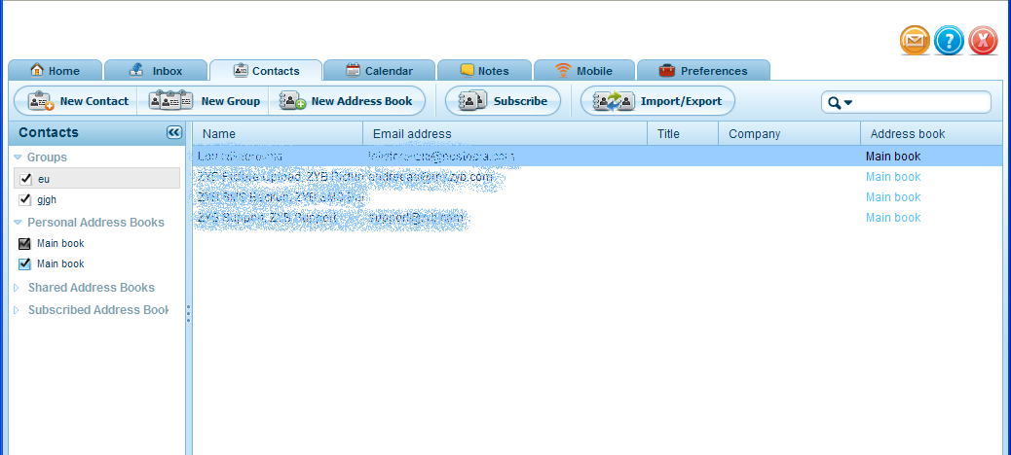
Preview and Editing Panel

Contacts Panel

Secondary Contacts Menu

a) Contacts Panel
The Contacts Panel allows you to choose which contacts to display in the Contacts Listing Panel.

There are four options to choose from:

  - Groups: This will display only the contacts belonging to the selected group in the Contacts Panel. To display the contacts from a specific group, select that group name from the selection box and its content will load in the Preview and Editing Panel.

Groups are used to sort and manage your contacts for easy reference. You can create groups for such contacts as “Friends”, “Coworkers”, “Family”, etc.

  - Shared Contacts are email addresses being shared across a domain.
You can view this contact list via your WebMail 6.0 Contact list. This feature can be toggled on or off when editing a contact. You cannot remove a shared contact that has not been added by you.

Collaborative Services such as Shared Contacts, Calendars, Tasks, and Notes must be enabled for a domain.

b) Preview and Editing Panel
The Preview and Editing Panel allows you to display, create, and edit contact, group, and list information.

2) Create Contacts
To create a contact, click the “New Contact” icon in the Secondary Menu. This will display a blank New Contact form in the Preview and Editing Panel. You must provide a Name and Email Address for your new contact. All other contact information is optional.

New Contact Form

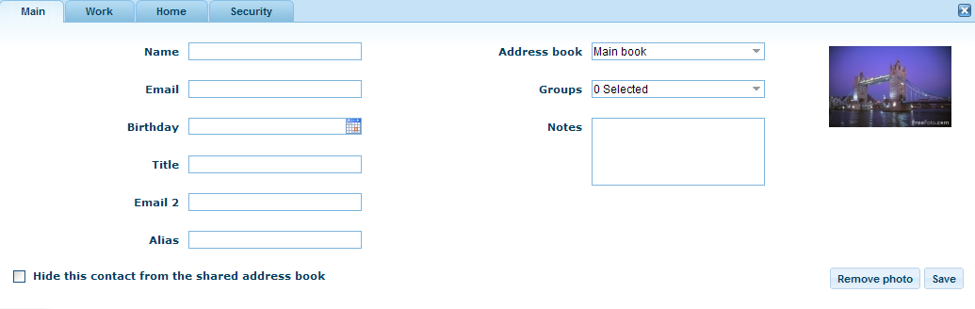
Fill in Fields
Shared
Contact

At the bottom of the New Contact form, click “Save” to create the contact. Click on Work tab, Home tab if you want to enter more specific information regarding the contact.

3) Edit Contacts

To edit an existing contact, select the contact. This will display the Edit Contact form in the Preview and Editing Panel. This is the same as the New Contact form however the contact’s current information will be displayed in the fields. You may edit any of the contact’s information fields.

At the bottom of the Edit Contact form, click “Save” to apply the change to the selected contact. Click the different tabs on top of the form to view and edit more information.

4) Delete Contacts

To delete a contact click the “Delete” button at the bottom right corner of the Edit Contact form. This will prompt you to delete the contact. Click “Ok” to permanently delete the contact.

5) Upload a photo

You may upload a photo for each contact by clicking on “Upload photo”. You will be prompted to locate the photo you would like to upload.

Permanently deleted Contacts cannot be recovered.

5) Create Groups

New Group
To create a group, click the “New Group” icon from the Secondary Menu. This will display a blank New Group form. You must specify the Group Name. Click “Save” to create the group or “Cancel” to erase any editing.

New Group

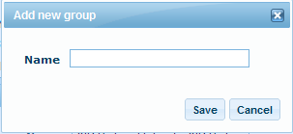
Group Name

6) Edit Groups

Edit a Group
To edit a group, click the group from the Contact Panel. This will display the Edit Group form in the Preview and Editing Panel. This is the same as the New Group form however the group’s current name will be displayed. You may edit the name. Click “Save” to apply the change to the selected group. Click “Cancel” to erase any editing and restore the group’s original name.

7) Delete Groups

Delete a Group
To delete a group, click the “Delete” button at the bottom left of the Edit Group form. This will prompt you to delete the group. Click “Ok” to permanently delete the group.

8) Import/Export Contacts

In order to import or export contacts click on the “Import/Export” button from the secondary menu.
You will be prompted with the following form:
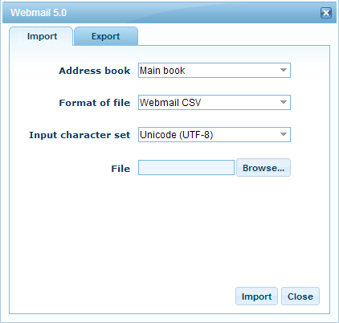

You may toggle among the tabs on top of the form depending whether you want to import or export contacts.

To import contacts:

- Choose an address book from the drop down menu. This address book will be the one that you will import the contacts into.
- Choose a file format from the drop down menu.
- Choose an “input character set” from the drop down menu.
- Click “Browse” to locate the file that you want to import.
- Click “Import” to import the file.
  - Click “Close” to exit the “Import/Export” form.

To export contacts:
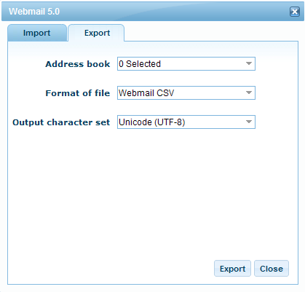
- Choose an address book from the drop down menu. This address book will be the one that you will import the contacts into.
- Choose a file format from the drop down menu.
- Choose an “output character set” from the drop down menu.
- Click “Export” to export the file.
  - Click “Close” to exit the “Import/Export” form.

Calendar

With the Calendar feature, you may perform the following tasks:

- Edit Calendars
- View the Calendar (Day View, Week View, Month View)
- Create Events (New Event)
- View Events
- Edit Events
- Delete Events
- Create a New Calendar
- Search event
- Add a new task

Secondary Calendar Menu

Collaborative Services such as Shared Contacts, Calendars, Tasks, and Notes must be enabled for a domain.

1. a) Edit Calendar
- Click the “Calendar” Icon.
- On the left side of the screen there is a list of “Calendars” with subtitles:
- Double click on the title of your calendar (i.e. My Calendar) to begin editing. (Please note the link by default will be user.domain.com). A screen should now appear on the right side which will allow you to edit your calendar.
Calendars Information

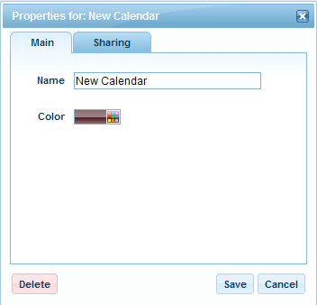
Title of Calendar

- Fill in/change the following information:
  - Name (Name of your Calendar, i.e. “My Calendar”)
  - Click the color palette (To the right trail your mouse over the color gradient, click on your preferred color)
  - Click on “Shared” tab. Here you can share your calendar with the entire domain or specify the email accounts you wish to share your calendar with.
  - Click “Save” to save the changes and click “Cancel” to dismiss the changes.

When typing in the email account you wish to share your calendar with, type only the first portion of the email address before @domain.com. (i.e. bill@domain.com = bill)

b) Subscribe to a Calendar
Other email account owners on the domain can make their Calendars available to you. You will have to check Available Calendars to view if any email account owners have shared their calendars with you.

c) Check Available Calendars
Available Calendars

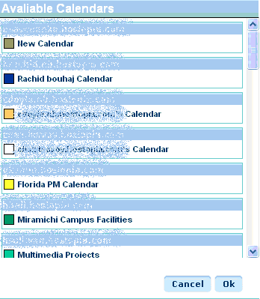

2) View the Calendar
Calendar view allows you to view your calendar daily, weekly, monthly.
- Calendar List
- Day View
- Week View
- Month View

a) Calendar List
A calendar list will be located on the left side of the calendar.
It will indicate which Event Titles belong to whom. You can customize the Calendar colors by clicking on the Calendar Name.
Calendar List
.

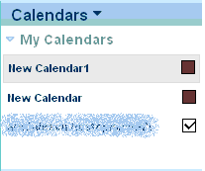

Editing Shared Calendar Information

- Double click on shared calendar Name you wish to edit (i.e. Bill’s Calendar).
- Type in the new Name of the shared calendar.
- Select Color (To the right trail your mouse over the color gradient, click on your preferred color).
- Click “Save.”

- Day View
The Day View displays all half hours of the selected day in a detailed grid format.

By default the Day View is set to the current date accessed. To advance to a future day, click the arrow pointing to the right. To retreat to the preceding day, click the arrow pointing to the left.

Calendar Day View
Hourly Breakdown

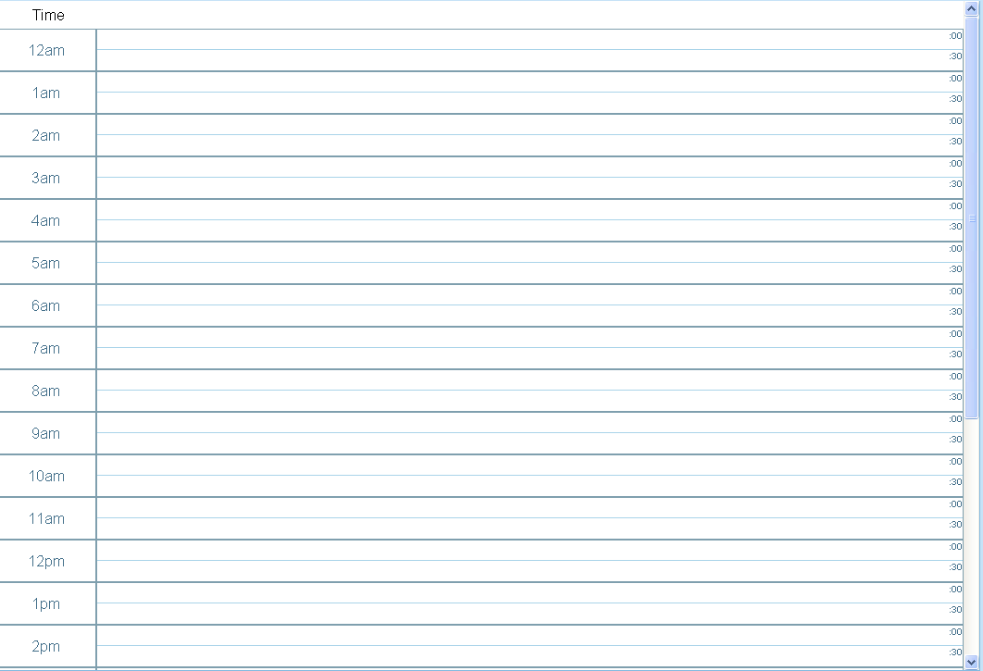

Events scheduled for specific hours will be displayed as colored blocks on the grid.

Action | Description
Click “New Event” | Click on this button to enter an event for the chosen date and time.
**Event Title | Click the title of a listed event to view that event.
**Event Edit | Click on the Event Title located on the calendar.
**Event Delete | Click on the name of the event within the calendar. Anew window will open, click “delete “on the bottom left corner in order to delete the event.
** | These actions can only be done once an event has been created.

By default, the calendar will open on Month View for the current month.

b) Week View
The Week View displays all days of the selected week in a more detailed grid format.
Calendar Week View
Hourly Breakdown
Daily Breakdown

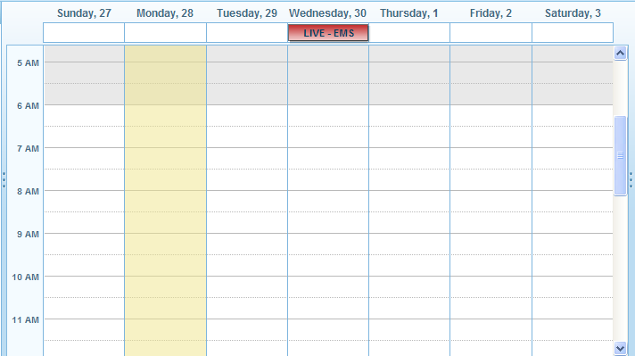

Events scheduled for specific days and specific times will be displayed as colored blocks on the grid.

Action | Description
Click “New Event” | Click on this button to enter an event for the chosen date and time.
**Event Title | Click the title of a listed event to view that event.
**Event Edit | Click on the Event Title located on the calendar.
**Event Delete | Click on the name of the event within the calendar. Anew window will open, click “delete “on the bottom left corner in order to delete the event.
** | These actions can only be done once an event has been created

c) Month View
The Month View displays all days of the selected month in grid format.

Calendar Month View

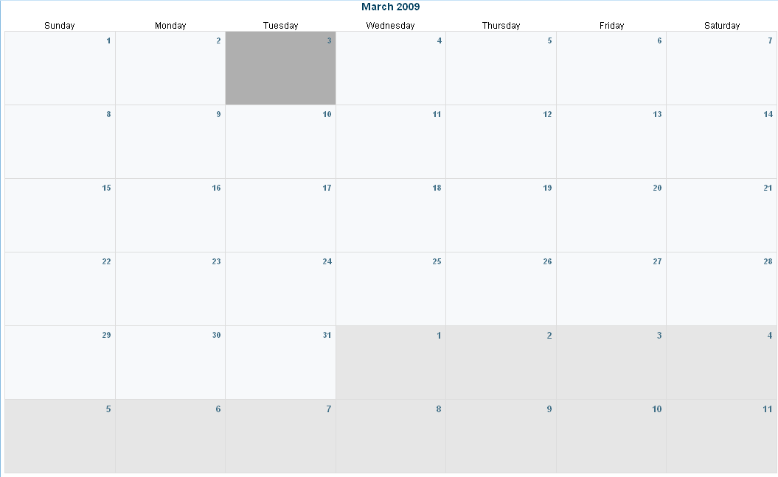

The current day appears in dark grey.
Days from the following month appear in light grey.

Action | Description
Plus (+) | Click the plus sign (+) of a specific day to enter an event for the chosen date.
**Event Title | Click the title of a listed event to view that event (if an event appears that day).
**Event Edit | Click on the Event Title located on the calendar.
**Event Delete | Click on the name of the event within the calendar. Anew window will open, click “delete “on the bottom left corner in order to delete the event.
** | These actions can only be done once an event has been created

Ways to Create Events
There are four ways to add an event to your calendar:

- Month View: In Month View, click the plus (+) in the square of a specific day to add an event.

- Week View: In Week View, click the “New Event” button at the top of the calendar to add an event.

- Day View: In Day View, click the “New Event” button at the top of the calendar to add an event.

- New Event Button: Click the “New Event” button on the left of the Secondary Menu to add and event.

Permissions to edit shared Calendar Events are administered by the appropriate email account.
New Calendar Event
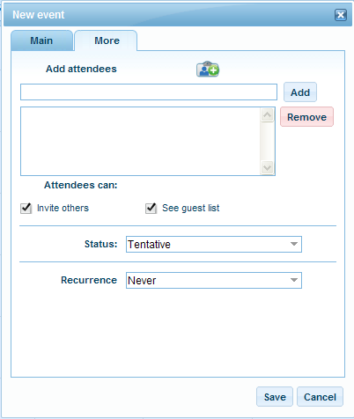
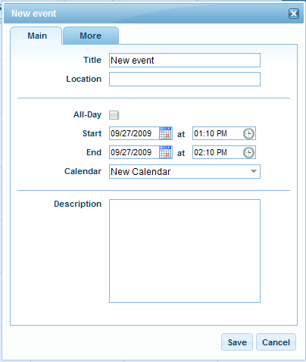

Calendar Events
The New Calendar Event window allows you to perform the following tasks:

- Create a Title: Select the title for the new event.

- Select Location: Select the location for the new event.

- Type Description: Type a description of the new event.

- Select Status: Select a status for the new event (i.e. Tentative, Confirmed, and Cancelled).

A cancelled event will still appear on the calendar. The event title will be stricken-out to indicate that the event has been cancelled.

- Select Begin and End Date and Time: Select the date and time at which the event will begin and end.

- Select Attendees: Click the “Add Contact” icon to add an attendee from your contact list to this event. This will open a bubble listing all your contacts as well as any lists created in the Contacts window. Select a contact or a list to attend the event. Click the “X” to close the bubble.

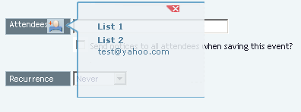
Click to Close
Click Add Attendees
Select Contact
List
Select Attendees

- Select Recurrence: Select how often the event will reoccur. If an event is set to reoccur, you will see it marked on the calendar for each specified date.

There are 5 options for the event reoccurrence status:
5 Statuses | Description
1. Never | The event will occur only once, as specified but the time and date.
2. Daily | After selecting this option, you will need to enter the number of days between the repeated events.
3. weekly | After selecting this option, you will need to enter the number of weeks between the repeated events as well at the day of the week the event will occur.
4. Monthly | After selecting this option, you will need to enter the number of months between the repeated events. The event will occur on the same day each month.
5. Yearly | After selecting this option, you will need to enter the number of years between the repeated events. The event will occur on the same day each year.

Click “Save” to save the event.

4) View Events

There a two ways to display a calendar event information on the screen
- Week View: In Week View, click the title of a listed event to view that event.

- Day View: In Day View, click the title of a listed event to view that event.

5) Edit Events

There are three ways to view an event into your calendar:

- Week View: In Week View, click the Event Title icon to edit an event.

- Day View: In Day View, click the Event Title to edit an event.

- Month View: In Month View, click the Event Title to edit an event.

Any one of these methods will display the Edit Event window. This is the same as the New Event window however the selected event’s information will be displayed. You may edit any of the event’s information.
Please note you are only permitted to edit your own Calendar as well as shared calendars you have permission to edit.

6) Delete Events
Click on the Event Title, a new window will open displaying the event information. Click on “delete” located on the bottom left in order to delete an event.

A deletion confirmation screen will be displayed. Click “Ok” to delete the Event. Click “Cancel” to save the event.

Permanently deleted Events cannot be recovered.

7) Create a New Calendar
Create a Calendar
- Click on “New Calendar” on the Secondary Menu. You will be displayed with a form that you will have to fill out in order to create a new calendar.
- Enter a name for the new calendar.
- Choose a color for your calendar by clicking on the color icon. A color palette will open where you will be able to choose a color.
- Click on “Sharing” tab if you would like to share your calendar. Here you can share your calendar with the entire domain or specify the email accounts you wish to share your calendar with.
- Click “Save” to save the changes and click “Cancel” to dismiss the changes. The new calendar will appear in the left panel under the list of calendars.

New Calendar

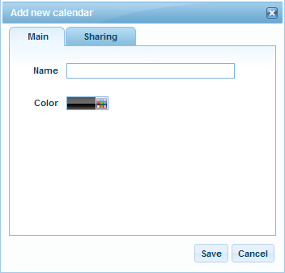
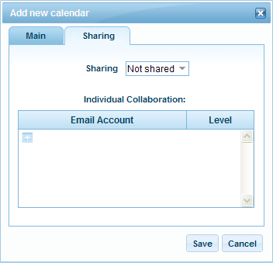

8) Search an event

- Click on “Search” button located on the secondary menu. The following form will be displayed.
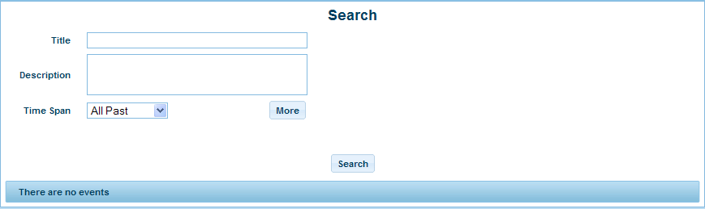

- If you click on “More” the following form will be displayed. Here you will have more advanced search capabilities.

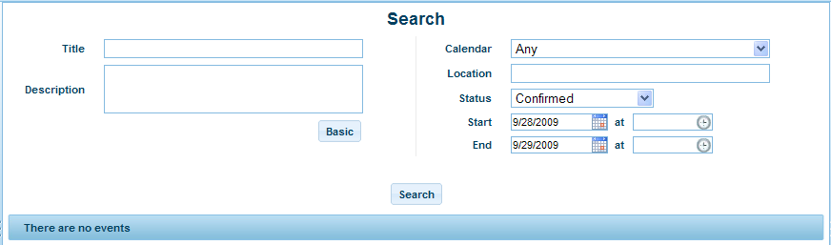

Fill out the fields. The more fields you fill out the better as it will enhance your search results.
- When done, click on “Search”. You will be displayed with the search results on the bottom of the form.

9) Add a new task

- Click on the “New Task” button located in the secondary menu. The following form will be displayed.
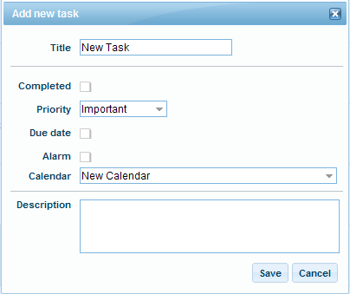
- Fill in the following information:
  - Name (Name of Task)
  - Check the “Completed” box if you want to add a task that’s already been completed.
  - Priority
  - Due by
  - Alarm
  - Choose the calendar (from the drop down menu) where you want this task to belong to.
  - Enter a brief description of the task.
- Click “Save”.

Shared Tasks
Using Shared Tasks, users can:
  - Access both Personal and Shared Tasks in one location while giving permissions as to what tasks are viewed by others within the company domain
  - Outline individual responsibilities and timelines within the tasks description
  - Create different task lists with different colleagues associated to each task
  - Set due dates and notification alarms for specific tasks

Collaborative Services such as Shared Contacts, Calendars, Tasks, and Notes must be enabled for a domain.

Notes

Notes allow you to input basic text information within one central location.

Sharing Notes
Authors can select from a list of users within their domain to identify who has access to notes and what they are allowed to do with the notes.

Collaborative Services such as Shared Contacts, Calendars, Tasks, and Notes must be enabled for a domain.

1) List Notes
Once you have created your notepad you will be able to view a list of notes.
List Notes shows all existing notes within the different Notepads.

2) New Note
Before a Note can be created you must create a Notepad.
- On the Secondary Menu, click “New Note.”
- Fill in the following:
  - Select Notepad from the drop down menu.
  - Note Text
- Click “Save” to create the note.

Note Information

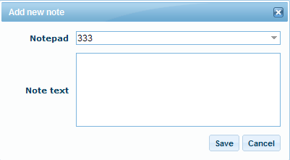

3) New Notepad

- On the Secondary Menu click “New Notepad”
- Fill in the following:
a) Name of the notepad
b) Color
c) Click “Sharing” in order to choose to share or not your notepad. Collaboration: not shared, low, medium, high.
d) Description
- Click “Save.”
New Notepad
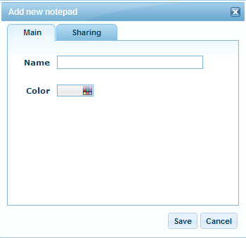
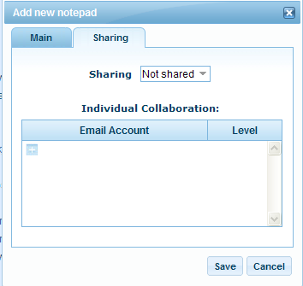

You can share your notepad by editing across your domain, or with specific email accounts hosted with the domain.

Editing Shared Notepad Information
- Fill in/change the following information:
- Name (Name of your Notepad, i.e. “Notepad1”)
- Color (To the right trail your mouse over the color gradient, click on your preferred color)
- Description

- Click the “Sharing” button (This is where you enable your shared Notepad options).
- A new screen will appear.
- You can share your notepad with the entire domain or specify the email accounts you wish to share your calendar with.
- Click “Save” to accept the changes.

Mobile
Mobile is divided into two sections:
- “SyncSuite” which enables you to download SyncSuite services which allow wireless data synchronization of Contacts and Calendars between multiple devices. Updating data on one device will lead to all devices being updated with the changes.
- “Mobile Email” which allows you to forward your email address to either a mobile device or another email account.
SyncSuite is only available with Collaborative Services.

1) SyncSuite
There are 4 SyncSuite clients to download:

- SyncJe for RIM Blackberry
- SyncJe for Outlook
- SyncJe for Outlook Express
- SyncJe for SyncML enabled wireless devices

- Click “Download” to download the application
- Click “Install Instructions” for detailed instruction on installing the application
- Click “Help File” for a guide on how to use these applications
Click on “Install Instructions” for guidance regarding installation.
Click on “Help Files” for help regarding SyncSuite.

2) Mobile Email
Allows you to forward you email address to receive mail on your mobile device or alternative email address.
Mobile Email

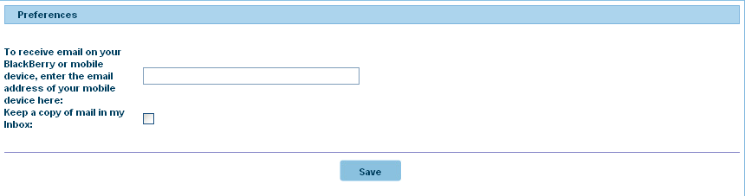

Set Email Forwarding
      - Enter the email address you wish to forward your email account to.
      - Check “Keep a copy of forwarded mail in my inbox,” if you wish to retain a copy of the mail in your email box.
      - Click “Save.”

If you set forwarding in this section, it will auto update in Preferences section so that you will not have to update forwarding elsewhere in WebMail.

Preferences

With WebMail 6.0 Preferences you can manage the following options:
- Mail Preferences
- Spam Preferences
- Change Password
- Auto reply Messages
- Filtering Preferences
- Highlighting Messages
- Image rules

Preferences
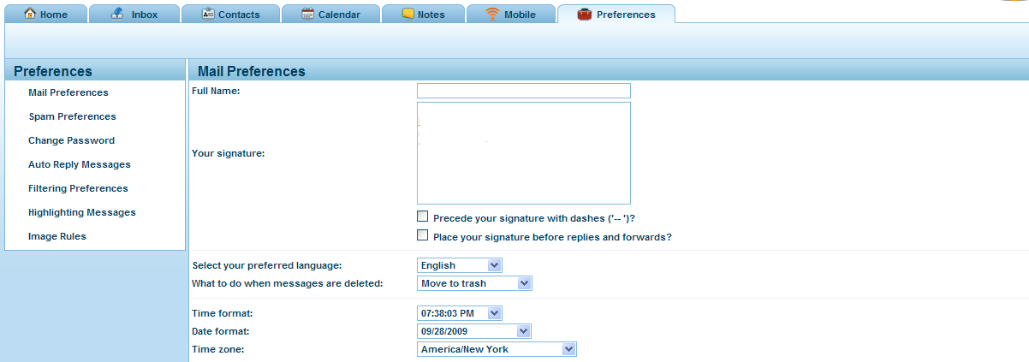

Preference
Panel

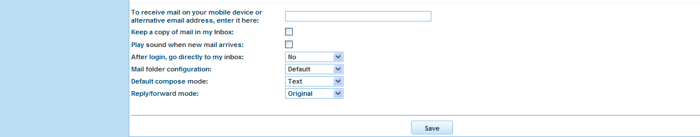
Preferences Options

1) Mail Preferences
Mail Preferences

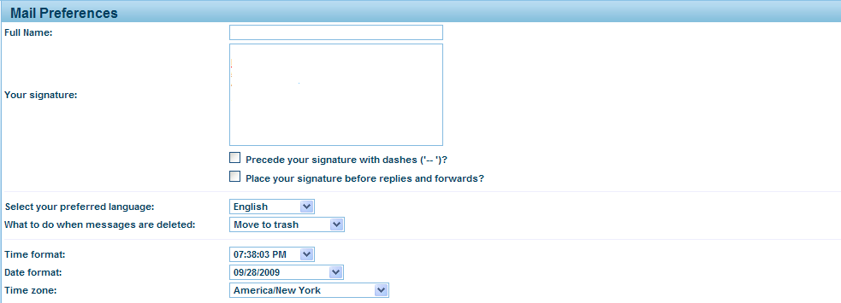
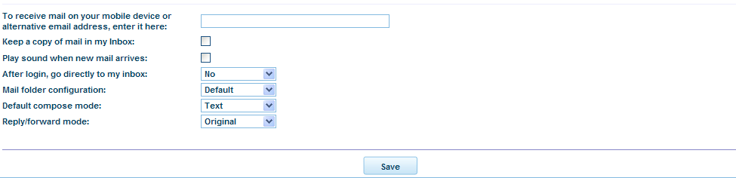
With Mail Preferences, you can set the following options:

- Full Name: Your Full Name is what is displayed in the “From” field of messages you send.

- Your signature: Your signature is the text that appears at the end of each message you compose. There are 2 checkboxes underneath with the following options

  - Precede your signature with dashes ('-- ')? Check this option if you would like a line of dashes to be automatically inserted before your signature in email messages you compose to visually separate the signature from the body of the email message.
  - Place your signature before replies and forwards? Check this option if you would like the appended text from a reply to appear below your message and signature. By leaving this checkbox blank, this option will place your signature after all appended text in a reply.

- Select your preferred language: You can select your preferred language to display the WebMail 6.0 interface. Available languages are: English, Français, Español, Italiano, Português, Deutsch.

- What to do when messages are deleted: You can either “Move to Trash” or “Permanently delete” messages.

- Time Format: This allows you to adjust the time to a format you prefer.

- Date format: This allows you to adjust the date to a format you prefer.

- Time zone: This allows you to set the time zone.

- To receive mail on your mobile device or alternative email address, enter it here: This option forwards all your mail to a specified email address.

- Keep a copy of mail in my inbox: If this option is checked, mail will be delivered both to your account and the forwarding account.

- Play sound when new mail arrives: You can choose yes or no to enable the sound alert for newly arrived email messages.

- After login go directly to inbox: From the drop down menu you may select “Yes,” if you wish to go directly to inbox after logging in; or select “No,” if you wish to view the home page with Quick Links.

- Mail folder configuration: The options available here are: Default, Apple Mail, Blackberry, Outlook, Thunderbird, And Aplus.

m) Default compose mode: The two options available are “text” or “html”.
  - Text: This option allows you type your message in plain text without any special formatting.
  - HTML: This option allows you to type your message using HTML code to specify special formatting. You may change the font face, size, color and weight as well as include bullets, indents, text justification and background color.

n) Reply/Forward mode: This option refers to the format of the text of the email messages that you choose to reply to or forward. The options available here are: “Original”, “text” or “html”. Original refers to keeping the format the same as it was received in.

2) Spam Preferences

Spam Preferences set spam filtering options for your email account. With Spam Preferences, you can set the following options:
- Spam Filtering
- Sensitivity Level
- Delivery Option

Filtering Preferences

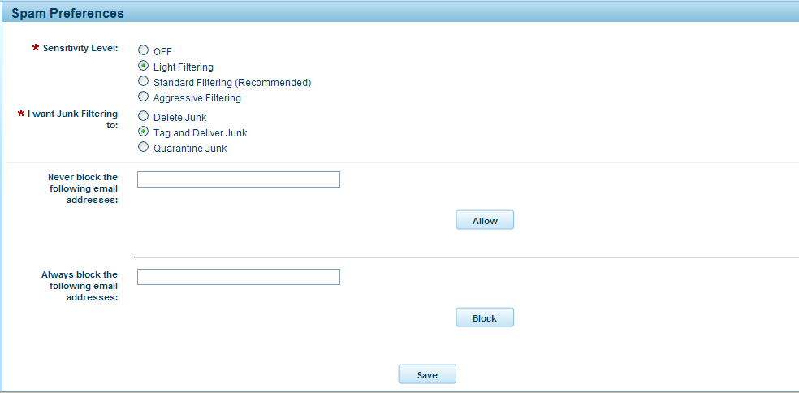
a) Spam Filtering
    - Turn Spam Filter ON: By enabling spam filtering for an account, every email which enters your inbox is evaluated and assigned a point value by an automated filter, based on the message headers and each email's content. If the point total is over a specific value, the email is categorized as spam. The subject, message formatting, and message headers are all examined for "spam-like" features.

  - Turn Spam Filter OFF: No messages are evaluated for "spam-like" features.

While the Spam Filter is an excellent method to limit spam, there is the potential for legitimate emails to be classified as spam and deleted, if this feature is enabled.

By disabling spam filtering for an account, all email will bypass the spam filter and be delivered directly to your mailbox.

b) Sensitivity Level
    - Light Filtering: Light Filtering sets the spam filter to a low sensitivity level. This setting will let through more spam, but is less likely to accidentally identify legitimate email as spam.

    - Standard Filtering (Recommended): Standard Filtering sets the spam filter to a high sensitivity level. This setting has a typical 95% to 99% success rate for discriminating between spam and legitimate email. This is the default setting.

    - Aggressive Filtering: Aggressive Filtering sets the spam filter to a very high sensitivity level. This setting increases the chances that legitimate email will be classified as spam.

c) I want Junk Filtering to
    - Delete Spam: This option will automatically delete all email flagged as spam. Emails classified as spam will not be delivered to your inbox and will be irretrievable once automatically deleted.

    - Tag and Deliver Spam: This option delivers all email flagged as spam to your inbox with “*****SPAM*****” added to the start of the subject line. You may sort these messages into another folder and delete them after review. *Tag and Deliver is the default setting.

    - Quarantine Spam: This option automatically places all email flagged as spam into a “Junk” folder. These messages will also be accessible through the email configuration tool in your web hosting control panel.

3) Allow/Block Lists

When an email is received from an address placed on the "Always Allow List” it is delivered to your inbox as regular email, despite anything the spam filter may find. Add email addresses to this list you wish to be certain you receive e-mail from, no matter how you have configured the spam filter.

When an email is received from an address placed on the "Always Block list” it is treated as spam, despite anything the spam filter may find. Add email addresses to this list if there are addresses you wish to be certain you never receive email from, no matter how you have configured the spam filter.

With Allow/Block Lists you can perform the following actions:
- Add an Always Allow/Block List entry
- Remove an Always Allow/Block List entry

a) Add an Always Allow/Block List entry
Allow
- To add to the Always Allow list type the full email in the text box to the left of the “Never block the following email addresses:”
- Click the “Allow” button.
- The added email or domain will display in the box below the textbox along with any other allowed entries.
Block
- To add to the Always Block list, type the full email in the text box to the left of the “Always block the following email addresses:”
- Click the “Block” button.
- The added email or domain will display in the box below the textbox along with any other blocked entries.

b) Remove an Always Allow/Block List entry
- Check the checkbox to the left of the entry
- Click “Remove Selected” button for the current list.

Entries in your block will be handled according to the filtering settings. For example if you current have your spam filter set to 'Tag & Deliver,' all entries in your block list will be automatically marked as spam regardless of their spam score, and delivered into your mailbox in the same fashion as other email determined to be spam.

3) Change Password

With Change Password you can change your current password by typing the current password once and typing the newly chosen password twice – to confirm you’ve accurately entered your new password.

Change your Password
- Type in current password in “Current Password.”
- Type in new password, “New Password.”
- Type in new password again in “Confirm Password.”
- Click “Save.”
Change Password
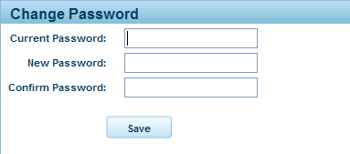

4) Auto Reply Messages

With Auto Reply Messages, you can automate a reply with a pre-written message to all or certain email messages sent to your email account.

For example you could set up an autoresponder when you are out of office for a few days which could alert those emailing you that you are away.
Auto Reply Messages

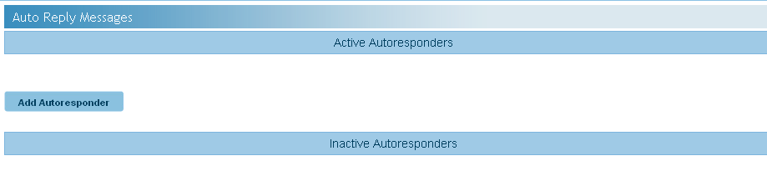

With Manage Autoresponders you can perform the following actions:
- Create Autoresponders
- View Active and Inactive Autoresponders
- Activate or Deactivate Autoresponders
- Edit Autoresponders
- Delete Autoresponders

a) Create Autoresponders
To create an autoresponder, click the “Add Responder” icon. This will take you to the Add Responder screen. Here you may set the following options:
  - Condition: You may specify to respond only to specific messages sent to your account as opposed to all messages.

You may select one of the following email header fields in which the Condition Text will be applied:
    - All
    - From
    - To
    - CC
    - Subject

  - Condition Text: Specify the text which an incoming message must contain in its Condition email header field for you autoresponder to be sent.

  - Message: In the large textbox to the right of “Message:” type the messages you would like the autoresponder to email as a response.

At the bottom of the Add Responder screen, click “Save” to create the autoresponder or “Cancel” to exit the Add Responder screen without creating the autoresponder.

By default, a newly created autoresponder will appear in the Inactive Responder list.

b) View Active and Inactive Autoresponders
Active responders will be displayed in the top box below “Active Responders”.
Inactive autoresponders will be displayed in the bottom box below “Inactive
Responders”.

Manage Autoresponders

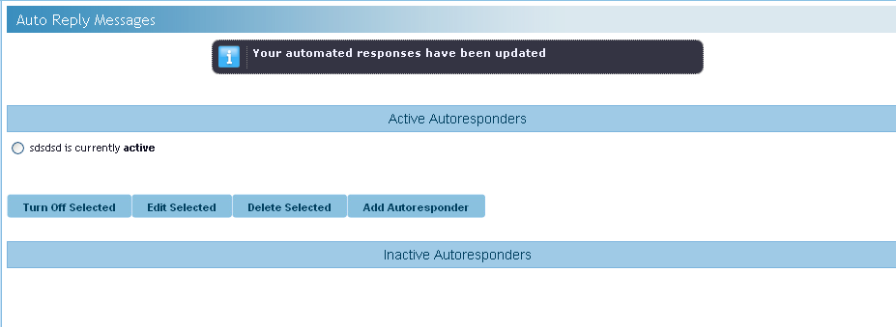
Select Responder
Choose Option
Click to Add
c) Activate or Deactivate Autoresponders
To activate an autoresponder, check the check box to the left of the autoresponder in the “Inactive Responder” box and click the “Turn on Selected” icon.

To deactivate an autoresponder, check box to the left of the autoresponder in the “Inactive Responder” box and click the “Turn off Selected” icon.

d) Edit Autoresponders
To edit an autoresponder, check the check box to the left of the autoresponder in either the “Active Responder” or the “Inactive Responder” box and click the “Edit Selected” button. This will display the Edit Responder form in the Preview and Editing Panel. This is the same form as the Add Responder form however the autoresponder’s current information will be displayed in the fields. You may edit any of the autoresponder’s information fields.

At the bottom of the Add Responder screen, click “Save” to apply the change to the autoresponder or “Cancel” to exit the Edit Responder screen without saving the changes to the autoresponder.

e) Delete Autoresponders
To permanently delete an autoresponder, check the box to the left of the autoresponder in either the “Active Responder” or the “Inactive Responder” box and click the “Delete Selected” button.

Permanently deleted Autoresponers cannot be recovered.

5) Filtering Preferences

This functionality will let you set up certain rules and conditions for your incoming email messages in your account.

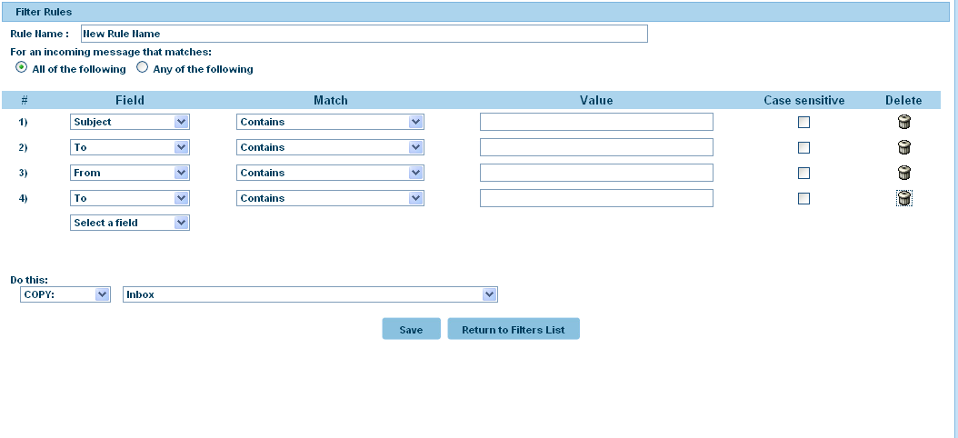
To setup a message rule:

- Under “Filtering Preferences” section click “New Rule” to add a new message rule.
- When you click on “New Rule” a new window will open and will let you set up the new rule. In this panel you can configure your message rule.

- Enter the rule name in the “Rule Name” text box.

- Under the heading “For incoming message that matches” select the option desired:” All of the following” or “Any of the following”. This selection is related to your condition that you will setup in the following steps.

- Select from the “Field” drop down menu on of the following: To, From, CC, Subject. The condition set will apply to the filed selected here.
- From “Match” drop down menu select one the conditions provided. For example if you want “To:” field containing specific text, you would choose “contains” and under “value” enter the text that would be contained in the field selected. If you want to setup the condition for case-sensitive text contained in the field check the check box under the “Case-sensitive” heading.

7. Now select the action to be performed under the conditions entered above. Under “Do this:” select from the two drop-down menus the desired action. For example if you want all email messages satisfying the condition set above , choose “Copy” from the drop down menu and choose “Junk” from the second drop down menu. This would mean that all messages satisfying the condition chosen will be copied into the Junk folder.

8. If you want to add more conditions under the same rule name select a different field or the same field again from the “Field” drop down menu and you will be able to create another condition under the same rule name.

9. If you are done click”Save” to save your work. Once you click “Save” you will be able to see your rule by clicking on the “return to filters list” Here you can see your rule and can make modifications to it.

10. In the “”Filter Rules” section click on to edit the rule (a new window will open displaying the details of your rule), click to delete the rule; click to copy the new rule name.

6) Highlighting Messages

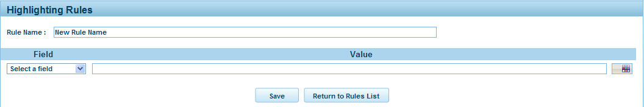

Enter a name for your rule.
- Select a filed from the drop down menu. The possible fields are: “To”, “Subject” and “From”.
- Enter the data relevant to the field selected. For example if you have selected “Subject” enter the subject(s) of emails that you wish to be highlighted when received.
- Next, select color to be highlighted with the message containing the subject line that you have entered in the previous step. In order to select a color, click on the color icon. A color palette will be displayed from where you will be able to select a color.
- Click “Save” to save the changes you have made.
  - Click “Return to Rules list” if you would like to view and select an existing rule from the list of the existing rules.

7) Image Rules

This section lest you manipulate the images sent or received.
You may also set up new rules regarding the manipulation of images received or sent.

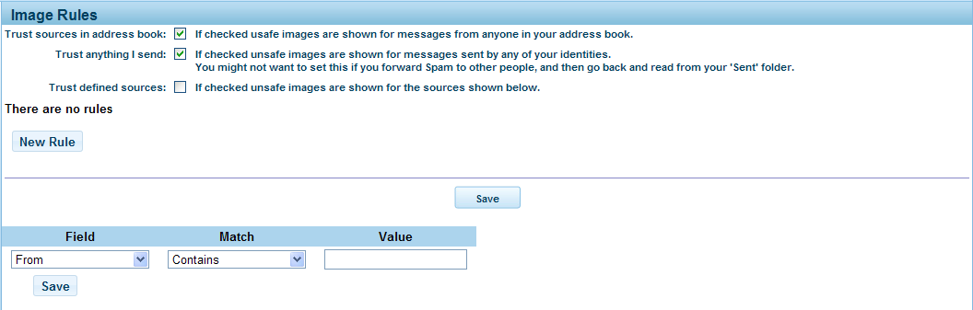

There are several options available to choose from:
  - Show unsafe images for messages from anyone in your address book
  - Show unsafe images for all messages you send.
  - Show unsafe images for the new rule that you set up.

In order to enable these options check off the corresponding checkbox.

In order to create a new rule, click on “New Rule” button. You will be displayed with an extended page where you can set up your rule.

- Select from the “Field” drop down menu one of the following: To, From, CC, Subject. The condition set will apply to the filed selected here.
- From “Match” drop down menu select one the conditions provided. For example if you want “To:” field containing specific text, you would choose “contains” and under “value” enter the text that would be contained in the field selected.
- If you are done click”Save” to save your work. Once you click “Save” you will be able to see your rule.
- Click to delete the rule.

Find Messages

It is possible to conduct a keyword search of your email messages. To perform a search, type the keyword in the “Find” textbox located in the Main Menu of the Inbox window.

Type Keyword

Hit “Enter” to perform the search.

Messages containing the specified keyword will be displayed in the Mail Listing Panel. If no messages contain the keyword, the Mail Listing Panel will state “No messages matched your search.”

To perform an advanced search, click the icon. You may refine your search according to the following criteria:

Message fields
The message fields are as follows:

- Sender: Type the sender’s email address of the message you are searching for.
- To: Type the receiver(s) email address(es) of the message you are searching for.
- CC: Type the receiver(s) email address(es) that received a copy of the message you are searching for.
- Subject: Type the keyword appearing in the subject line of the message(s) you are searching for.
- Entire Message: Type the keyword appearing in the body of the message(s) you are searching for.

Manage Personal Folders

In addition to the default folders, you may create your own folders to organize your messages.

The Personal Folders feature allows you to perform the following tasks:
- View Personal Folders
- Create Personal Folders
- Rename Personal Folders
- Delete Personal Folders

- View/Hide Personal Folders
The personal folders you create will appear below the main Personal Folders icon.

Display Personal Folders
To display your personal folders, click the Personal Folder icon or name this will display all your personal folders below the main Personal Folder icon.

Hide Personal Folders
To hide your personal folders, click the Personal Folder icon or name. This will hide your personal folders from view.
Mail Folders

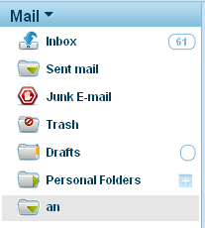
Personal Folder

- Create Personal Folders
To create a personal folder, click button located to the right of the Personal Folder icon or name. This will display a text box where you can name your folder.
Mail Folders

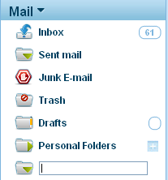
Click to add a new folder
Enter a name of the new folder New Folder

Enter the folder name. The new folder will be placed below the main Personal Folders icon.

- Rename Personal Folders
To rename a personal folder, right click the chosen folder in the Mail Folder Panel. Select “Rename Folder” from the menu. You will then be prompted to change the folder name. Enter the new folder name. The folder’s new name will appear below the main Personal Folders icon.

- Delete Personal Folders
To delete a personal folder, right click the chosen folder in the Mail Folder Panel. This will display a menu. Select “Delete Folder” from the menu.

Deleting a personal folder will permanently delete all messages contained in the folder. These messages cannot be recovered once deleted.

WebMail 6.0 for PDAs

If you have a device that supports viewing WAP (Wireless Application Protocol) based web pages you can view WebMail 6.0.

1) Login
On your PDA go to http://webmail.domain.com/pda you will be able to log in with your email account as you would on your general web browser on your personal computer and gain access to your emails in your account.

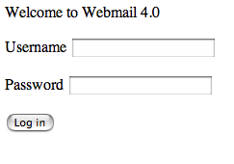
WebMail 6.0 PDA Login

The login screen will prompt you for your username which is your email address and the password associated with it. Once you have successfully logged in, you will be automatically brought to you Inbox to view the latest mail that was received in your account.

The Inbox will show you the following:
- The last 5 messages that were received into your account with the sender’s name and the subject of the message.
- New messages that have not been viewed will be marked with an ‘N’ beside them for the user to distinguish. Messages that the user has already replied to will also be denoted with an ‘r’ beside them in the inbox.
- The inbox will display only 5 messages per page.

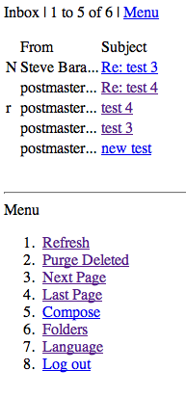
Inbox

2) Message View

View a Message
- Highlight the subject of which message you wish to view.
- Click on the subject title

This will open the message in a new window for the user to view its contents.

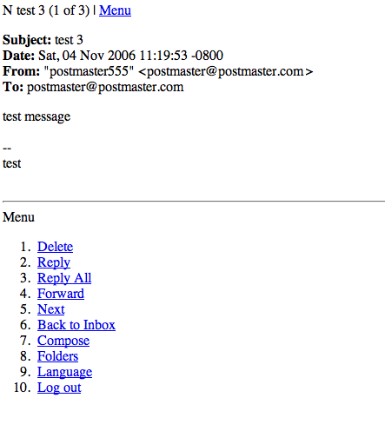
Message View

If the user deletes a message, when they return to the Inbox, they will see a ‘D’ denoted beside the message that they deleted. They can then execute the ‘Purge Deleted’ option available to them to permanently remove the message from their mailbox.

3) Compose

To compose a message, use the ‘Compose’ option in the menu which will load the compose screen for a new message to be sent.

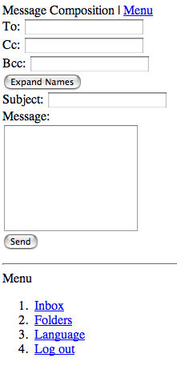

Expand Names

The ‘Expand Names’ option allows the user to begin to type a contact which already exists in their contact list and then click on ‘Expand Names’ which will then auto complete their contact’s email address in the current field.

Once the user has sent the message successfully, they will be reverted back to the Inbox.

4) Language Support

The language component of the WAP application will list the 6 supported languages of WebMail 6.0. The user can select any of the languages to translate the application into their desired language.

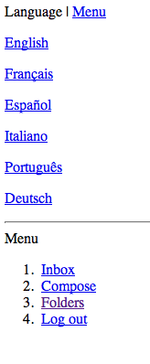
Languages

5) Log Out

Once you have selected to log out of the WAP interface through any of the menus, the default login page will then be displayed for login at next convenience.

Disk Usage & Collaborative Services FAQ

Q: Will disk usage also include junk mail folders for my email?

A: Yes, disk usage will take into account all email folders (i.e. junk mail) associated with an email account.

Q: How much disk space does my email account have?

A: The disk space allotted to your email accounts is detailed in your hosting plan. You can also view your disk space by visiting the WebMail 6.0 Home Page, simply click on the “Home” icon at the top and then under the Statistics section click on “More”.

Q: How do I increase my disk space for my email?

A: If you think that you require more disk space than your current package allows you can speak to a Sales Representative about upgrading your package. Please note, a lot of SPAM email can build up in your Junk folder, this can sometimes account for limiting your disk space. To avoid SPAM email from using up your disk space it is best to empty your junk mail folder periodically. To empty your junk mail folder select the folder and right click, an option to “Empty Folder” will appear. Select “delete” to empty the folder contents therefore deleting the spam and freeing up space.

Q: If I empty an email folder, will I be able to see the disk usage change right away?

A: Yes. If you empty a folder your disk usage will reflect that change immediately.

Collaborative Services Questions

About Your Contact Lists

Q: Can I use my shared contact lists in WebMail 6.0 with email clients (i.e. outlook, Thunder Bird)?

A: The Outlook Sync option allows you to synchronize your contacts from WebMail 6.0 to your any one of the popular email programs. If you do not currently have the Outlook Sync option, contact a Sales Representative to have it enabled. Synchronization can be overwritten from the client side application, there are the overwrite options settings available in WebMail 6.0.

Q: I do not wish to view shared contact list, how can I hide this feature?

A: If you do not want to view a shared contact list you can create a Group to view only your Personal Contacts.

Q: How can I differentiate between my contact list and the shared contact list?
A: Shared contacts are indicated by the icon.

Q: Can I remove a shared contact from my Shared Contact list?
A: Only the person who created the shared contact can delete, edit or add contacts.

Q: When I share a contact am I able to specify who has access to the contact?

A: No, contacts listed on a shared contact list will be shared amongst all email accounts related to your domain.

About Your Calendar

Q: How do I view a shared calendar?

A: To view a shared calendar, you must first subscribe to it. To show or hide a calendar in your calendar view, check or uncheck the box to the left of the calendar name.

Q: How do I share my calendar?

A: To share your calendar with other, click on the calendar name. This will take you to the options for that calendar. To change the sharing options for that calendar, click on the Sharing button and select the sharing options you want.

Q: Can I share my calendar with selected people?

A: Yes you can specify who you share your calendar with. To do this, click on the calendar name. This will take you to the options menu for that calendar. To change the sharing options for that calendar, click on the Sharing button. This will allow you to add various people and select their sharing permissions for your calendar.

Q: A shared calendar was in my calendar list, but it is no longer listed what has happened?

A: If this happens, then the person who created and shared the calendar has either deleted the calendar, or is no longer sharing it with you.

Q: When I click on all the boxes next to each calendar, how do I know which one I am viewing?

A: To the right of the calendar name, you will see a little colored square. The events for that calendar are displayed in that color.

About Notes & Tasks

Q: How do I share my notes and tasks?

A: To share a Task or Note, click on the Note Name. This will take you to the options for that item. To change the sharing options, click on the Sharing button and select the sharing options you want.

Q: How many notes & tasks can I make?

A: There is no limit to the amount of notes and tasks you can create.

Q: Once I have completed a task, do I have to manually move it into complete?

A: To mark a task as complete, just click on the checkbox. You can also edit the task, and mark it as complete

